[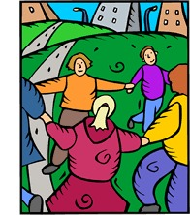](https://ord.yahoo.co.jp/o/image/RV=1/RE=1577666140/RH=b3JkLnlhaG9vLmNvLmpw/RB=/RU=aHR0cDovL3d3dy5iZXJsaXR6LmNvLmpwL3dtLzExYXR3b3JrLzAzMzEuaHRt/RS=%5eADBf4f4fJ_JS.MFqO2yS6rcLik8Eto-;_ylt=A2Riol7c9AdeE1oAbw2U3uV7;_ylu=X3oDMTBiaGxjcmduBHZ0aWQDanBjMDAy)

interact

[](https://ord.yahoo.co.jp/o/image/RV=1/RE=1577666002/RH=b3JkLnlhaG9vLmNvLmpw/RB=/RU=aHR0cDovL3d3dy5wdGEuY28udWsvYm9vc3QtcHJvZml0cy9pbnRlcnZhbC1nYW1lcy5hc3B4/RS=%5eADBHBos7yOS.ITHyWvM2ZhRlZ8HcJ0-;_ylt=A2RinF1S9AdeyQ8AfxeU3uV7;_ylu=X3oDMTBiaGxjcmduBHZ0aWQDanBjMDAy)

interval

[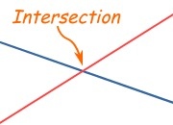](https://ord.yahoo.co.jp/o/image/RV=1/RE=1577665213/RH=b3JkLnlhaG9vLmNvLmpw/RB=/RU=aHR0cHM6Ly93d3cubWF0aHNpc2Z1bi5jb20vZGVmaW5pdGlvbnMvaW50ZXJzZWN0Lmh0bWw-/RS=%5eADBuVYaMlPRCnJsH5JzvEyjYheu0ro-;_ylt=A2RimVQ98QdeR08AhzeU3uV7;_ylu=X3oDMTBiaGxjcmduBHZ0aWQDanBjMDAy)

intersect

[](https://ord.yahoo.co.jp/o/image/RV=1/RE=1577666175/RH=b3JkLnlhaG9vLmNvLmpw/RB=/RU=aHR0cDovL3d3dy5uZXd0ZWNoc29jaWV0eS5vcmcvZmluZC1tb25leS1oaWRpbmctb24tdGhlLWludGVybmV0Lw--/RS=%5eADBM9C9pcHYXVRLWehFLTPalBteyVU-;_ylt=A2RinFP_9AdemRAAvDGU3uV7;_ylu=X3oDMTBiaGxjcmduBHZ0aWQDanBjMDAy)

internet

[](https://ord.yahoo.co.jp/o/image/RV=1/RE=1577666095/RH=b3JkLnlhaG9vLmNvLmpw/RB=/RU=aHR0cHM6Ly93d3cuZXhwb3J0ZXJzaW5kaWEuY29tL3ZhcnVuLXByZWNhc3QvaW50ZXJsb2NrLXRpbGVzLTQ3Nzk2NjIuaHRt/RS=%5eADBrvk7bYrpnKkghutcw55qT3IlkCE-;_ylt=A2RimFCv9AdeEBwA5guU3uV7;_ylu=X3oDMTBiaGxjcmduBHZ0aWQDanBjMDAy)

interlock

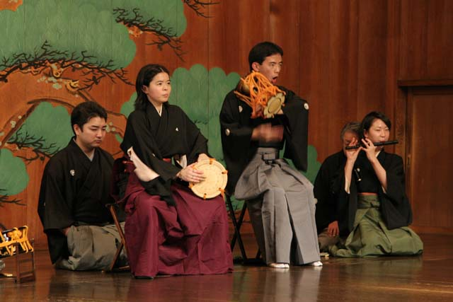

interlude

[](https://ord.yahoo.co.jp/o/image/RV=1/RE=1577665021/RH=b3JkLnlhaG9vLmNvLmpw/RB=/RU=aHR0cHM6Ly93d3cuZml0bmVzcy1nYW1pbmcuY29tL25ld3MvZXZlbnRzLWFuZC1mdW4vbmVidWxhLWludGVyYWN0aXZlLXdhbGwuaHRtbA--/RS=%5eADBRS_IRjBUC7MclsG8nvWhw50DkZE-;_ylt=A2RinFl98AdebGwATAKU3uV7;_ylu=X3oDMTBiaGxjcmduBHZ0aWQDanBjMDAy)

interactive

[](https://ord.yahoo.co.jp/o/image/RV=1/RE=1577664877/RH=b3JkLnlhaG9vLmNvLmpw/RB=/RU=aHR0cHM6Ly90YWxlbnRzYW5kc2tpbGxzLm5ldC8yMDE5LzA4LzA1L2hvdy1pbmR1c3RyeS1hbmQtcm9sZS1pbXBhY3QtdGhlLWludGVydmlldy8-/RS=%5eADBUyV2pIPjm8KWJfkymeQ4LbNCDJ8-;_ylt=A2Rivbrs7wdeCXgAMy.U3uV7;_ylu=X3oDMTBiaGxjcmduBHZ0aWQDanBjMDAy)

[](https://ord.yahoo.co.jp/o/image/RV=1/RE=1577664757/RH=b3JkLnlhaG9vLmNvLmpw/RB=/RU=aHR0cDovL3d3dy5pbnN0YXp1LmNvbS90YWcva2lkc2dldGFsb25n/RS=%5eADBnekWfnZQE1UX9PIJWkyhqYFB4qo-;_ylt=A2Riohd17wde4gQAtRmU3uV7;_ylu=X3oDMTBiaGxjcmduBHZ0aWQDanBjMDAy)interview

interject

[](https://ord.yahoo.co.jp/o/image/RV=1/RE=1577665077/RH=b3JkLnlhaG9vLmNvLmpw/RB=/RU=aHR0cDovL3d3dy4yMDB3b3Jkcy1hLWRheS5jb20vc3BhbmlzaC12ZXJiLWludGVydmVuaXIuaHRtbA--/RS=%5eADB8p82d1TN6SY_7eEbFygtnNI3Q7Y-;_ylt=A2Rivbi18AdeiQMA9hOU3uV7;_ylu=X3oDMTBiaGxjcmduBHZ0aWQDanBjMDAy)

intervene

[](https://ord.yahoo.co.jp/o/image/RV=1/RE=1577664922/RH=b3JkLnlhaG9vLmNvLmpw/RB=/RU=aHR0cDovL3d3dy5ob255YWt1LXBsdXMuY29tL2Jsb2cvMjAxNi8xMi8yNy9pbnRlcnByZXRpbmctd2h5LWlzLWl0LXNvLWV4cGVuc2l2ZS8-/RS=%5eADBvtsui_NllwIKIJRZGfdqZldLywU-;_ylt=A2RiolwZ8AdeCQIAsgCU3uV7;_ylu=X3oDMTBiaGxjcmduBHZ0aWQDanBjMDAy)

interpreter

[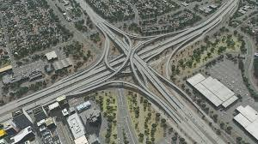](https://ord.yahoo.co.jp/o/image/RV=1/RE=1577664833/RH=b3JkLnlhaG9vLmNvLmpw/RB=/RU=aHR0cHM6Ly9zdGVhbWNvbW11bml0eS5jb20vc2hhcmVkZmlsZXMvZmlsZWRldGFpbHMvP2w9amFwYW5lc2UmYW1wO2lkPTEyOTY1NzQ4NDk-/RS=%5eADBzmRVFWO5eJy2Xooi3hITHRL3SKs-;_ylt=A2RivcTA7wdedkcAHRCU3uV7;_ylu=X3oDMTBiaGxjcmduBHZ0aWQDanBjMDAy)

interchange

[](https://ord.yahoo.co.jp/o/image/RV=1/RE=1577663990/RH=b3JkLnlhaG9vLmNvLmpw/RB=/RU=aHR0cHM6Ly93d3cuZHJlYW1zdGltZS5jb20vaWxsdXN0cmF0aW9uL2ludGVybG9wZXIuaHRtbA--/RS=%5eADB6Q5f_rkj0LAEMomM1euVBAumtfQ-;_ylt=A2RimE517Ade_zcAlBCU3uV7;_ylu=X3oDMTBiaGxjcmduBHZ0aWQDanBjMDAy)

interloper

[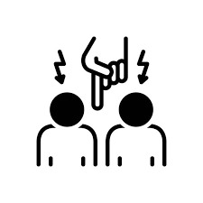](https://ord.yahoo.co.jp/o/image/RV=1/RE=1577662973/RH=b3JkLnlhaG9vLmNvLmpw/RB=/RU=aHR0cHM6Ly93d3cuaXN0b2NrcGhvdG8uY29tL2pwLyVFMyU4MiVBNCVFMyU4MyVBOSVFMyU4MiVCOSVFMyU4MyU4OC9pbnRlcmZlcmU-/RS=%5eADBvySyjO8bcDdYIujzROuAP.8fQKc-;_ylt=A2RivbF96AdeTEkABD2U3uV7;_ylu=X3oDMTBiaGxjcmduBHZ0aWQDanBjMDAy)

interfere

[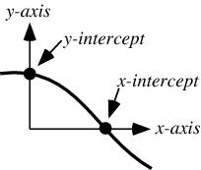](https://ord.yahoo.co.jp/o/image/RV=1/RE=1577662293/RH=b3JkLnlhaG9vLmNvLmpw/RB=/RU=aHR0cDovL21hdGh3b3JsZC53b2xmcmFtLmNvbS95LUludGVyY2VwdC5odG1s/RS=%5eADBy0K8jpnDhhxO_jNoUqA4PPSWLl8-;_ylt=A2RinFLV5QdeBREASQSU3uV7;_ylu=X3oDMTBiaGxjcmduBHZ0aWQDanBjMDAy)

intercept

[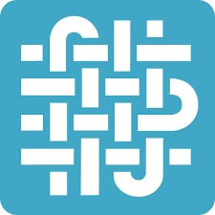](https://ord.yahoo.co.jp/o/image/RV=1/RE=1577664098/RH=b3JkLnlhaG9vLmNvLmpw/RB=/RU=aHR0cHM6Ly9qYS1qcC5mYWNlYm9vay5jb20vcGFnZXMvY2F0ZWdvcnkvQXJ0LUdhbGxlcnkvSW50ZXJ3ZWF2ZS5GQi9wb3N0cy8-/RS=%5eADBOfv_urOib9_l4fjqdDIxcXmSduo-;_ylt=A2RivcTh7AdeEjsAbzOU3uV7;_ylu=X3oDMTBiaGxjcmduBHZ0aWQDanBjMDAy)

interweave

[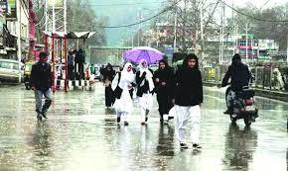](https://ord.yahoo.co.jp/o/image/RV=1/RE=1577663853/RH=b3JkLnlhaG9vLmNvLmpw/RB=/RU=aHR0cDovL3ByZWNpb3Vza2FzaG1pci5jb20vMjAxOS8wNC8yNS9pbnRlcm1pdHRlbnQtcmFpbnMtbGFzaC1rYXNobWlyLXRlbXAtZGlwcy8-/RS=%5eADByTXI5hPlavii0cFsiwbTwMOlBPo-;_ylt=A2RimU7t6wde61QAEDWU3uV7;_ylu=X3oDMTBiaGxjcmduBHZ0aWQDanBjMDAy)

intermittent

[](https://ord.yahoo.co.jp/o/image/RV=1/RE=1577662930/RH=b3JkLnlhaG9vLmNvLmpw/RB=/RU=aHR0cDovL29waW5pb2p1cmlzLm9yZy8yMDE5LzEwLzE0L2ludGVybmF0aW9uYWwtb3JnYW5pemF0aW9ucy1hY2NvdW50YWJpbGl0eS1zeW1wb3NpdW0tYW4taW50cm9kdWN0aW9uLw--/RS=%5eADBfaoFH7z6f9EcOr15L2iCipDqPBE-;_ylt=A2RivbhS6AdetBgAHTCU3uV7;_ylu=X3oDMTBiaGxjcmduBHZ0aWQDanBjMDAy)

international